## FLOOD MONITORING SYSTEM AND EARLY WARNINGS

## 

## Describe the project's objectives, IoT sensor deployment, platform development, and code implementation.

## l.Project Objectives:

## The primary objectives of this flood monitoring system project are:

## 1.Early Warning:

## To provide timely and accurate flood warnings to local authorities and communities, allowing them to take proactive measures to protect lives and property.

## 2.Flood Risk Assessment:

## To continuously assess the risk of flooding in specific areas, helping authorities in disaster preparedness and response planning.

## 3.Data Collection and Analysis:

## To collect data on weather conditions, rainfall, water levels, and other relevant parameters and analyze this data to make informed predictions about potential flooding events.

## 4.Community Engagement:

## To educate and engage the local community on flood risk and response procedures, making them an active part of the disaster management process.

## ll.IoT Sensor Deployment:

## 1.Sensor Selection:

## Choose a mix of sensors, including river gauges, rain gauges, weather stations, and water level sensors, based on the specific requirements of the project.

## 2.Sensor Placement:

## Deploy sensors strategically in flood-prone areas, near rivers, and at elevated points where they can accurately monitor water levels and meteorological conditions.

## 3.Data Transmission:

## Implement wireless communication technology (e.g., cellular, LoRa, or satellite) to transmit data from sensors to a central server.

## Ensure that sensor data is encrypted and secure during transmission.

## 4.Power Supply:

## Depending on the deployment location, use a reliable power source, such as solar panels, batteries, or a combination of both, to keep the sensors operational.

## lll.Platform Development:

## 1.Data Collection System:

## Develop a central platform to receive and store data from the deployed sensors.

## This platform should support real-time data ingestion and storage with redundancy and backup systems.

## 2.Data Processing and Analysis:

## Create algorithms and data processing modules to analyze the incoming data.

## Use historical data, machine learning models, and meteorological forecasts to predict potential flood events.

## 3.Warning System:

## Implement a notification system that can send alerts to local authorities and the public via multiple communication channels.

## Develop a user-friendly interface for monitoring and managing the system.

## 4.Scalability and Integration:

## Design the platform to be scalable and compatible with other disaster management systems and emergency response platforms.

## IV.Code Implementation:

## 1.Sensor Code:

## Develop firmware or software for the IoT sensors to collect data, process it, and transmit it to the central platform.

## Ensure that the sensor code is robust, and it includes error-handling mechanisms.

## 2.Data Processing Code:

## Write code to process and analyze the collected data.

## Use programming languages and libraries suitable for data analysis, such as Python and Pandas.

## 3.Predictive Models:

## Implement predictive models that take into account historical data and weather forecasts to assess flood risk.

## Machine learning frameworks like TensorFlow or scikit-learn can be used for this purpose.

## 4.Notification System Code:

## Develop code for the notification system to trigger alerts in response to potential flood events.

## This may involve integrating with SMS gateways, email services, or other communication APIs.

## 5.User Interface:

## Design and implement a web-based or mobile app interface to allow users to visualize real-time data, receive alerts, and access flood-related information.

## 6.Security and Encryption:

## Ensure the code and data transmission are secure by implementing encryption, access control, and other security measures.

**Include diagrams, schematics, and screenshots of the IoT sensors and early warning platform.**

## PIC 2.png

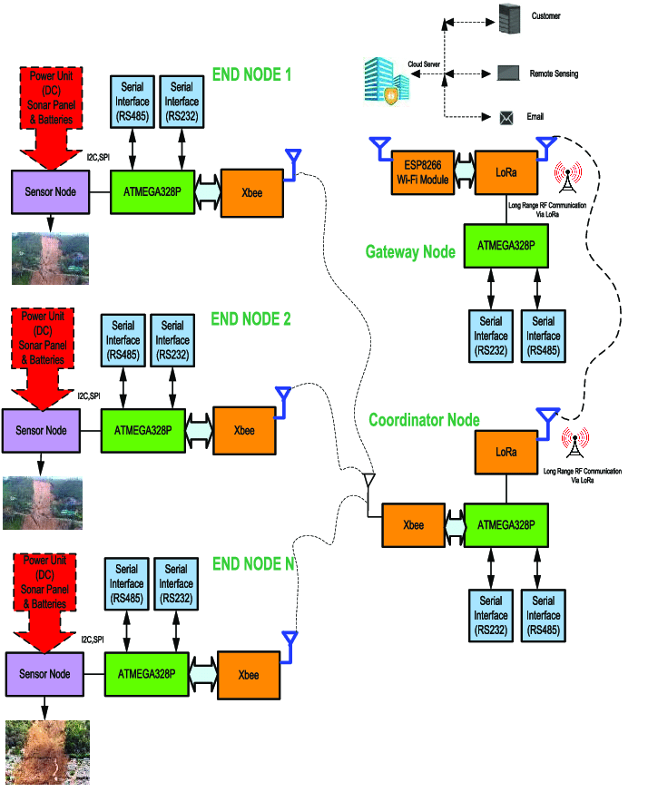

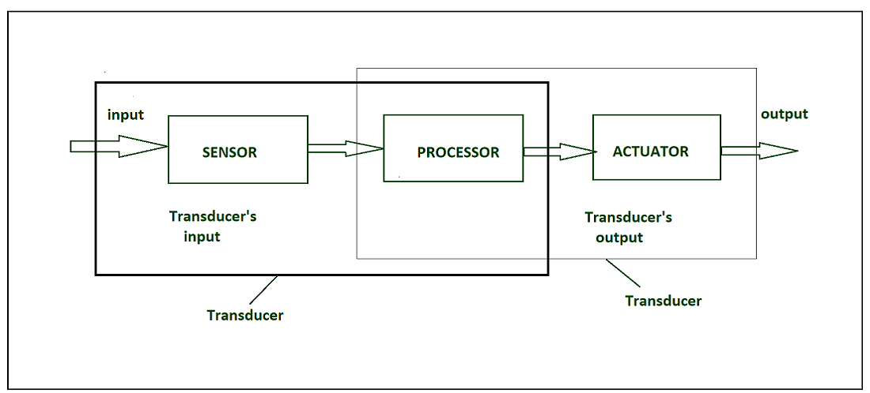

## Explain how the real-time flood monitoring and early warning system can enhance public safety and emergency response coordination.

## A real-time flood monitoring and early warning system plays a crucial role in enhancing public safety and emergency response coordination by providing timely and accurate information about impending flood events. Here's how such a system can make a significant difference:

## I.Early Warning and Preparedness:

## `1.Timely Alerts:

## The system continuously monitors weather conditions, water levels, and other relevant data.

## When it detects a potential flood risk, it can issue early warnings, often well in advance of an actual flood event.

## This early warning allows local authorities and the public to prepare for the impending danger.

## 2.Evacuation Planning:

## With advance notice, local authorities can plan and execute evacuation procedures more efficiently.

## They can identify vulnerable areas and populations that need to be evacuated and coordinate transportation and shelter arrangements.

## 3.Improved Decision-Making:

## Data-Driven Decision Support: Flood monitoring systems provide decision-makers with real-time, data-backed insights.

## This helps in making informed decisions regarding resource allocation, emergency response priorities, and the deployment of personnel and equipment.

## 4.Risk Assessment:

## By continually assessing the risk of flooding in specific areas, authorities can prioritize their response efforts, focusing on regions with the highest threat levels.

## This targeted approach optimizes resources and minimizes response time.

## 5.Enhanced Public Awareness:

## 6.Community Engagement:

## Flood monitoring systems often include public notification mechanisms.

## Residents receive alerts through various channels such as SMS, sirens, and mobile apps.

## This heightened awareness ensures that individuals are better prepared and more likely to take necessary precautions.

## 7.Informed Choices:

## With access to real-time data and alerts, the public can make informed choices about their safety.

## They can decide when to evacuate, which routes to take, and where to seek shelter, reducing the likelihood of accidents and injuries.

## II.Coordination and Communication:

## 1.Interagency Collaboration:

## The early warning system fosters collaboration among various agencies involved in disaster management, such as police, fire departments, emergency medical services, and government agencies.

## These entities can coordinate their efforts and resources effectively.

## 2.Communication Infrastructure:

## The system provides a centralized platform for communication and data sharing, ensuring that all relevant stakeholders have access to the same information.

## This minimizes confusion and prevents misinformation.

## III.Rapid Response:

## 1.Prepositioning Resources:

## Early warnings allow emergency response teams to preposition resources like boats, medical supplies, and rescue personnel in strategic locations, reducing response time and increasing the chances of saving lives.

## 2.Rescue Operations:

## With advanced knowledge of the flood's location and severity, rescue teams can be dispatched promptly to help individuals stranded or in distress.

## IV.Post-Flood Recovery:

## 1.Damage Assessment:

## After the flood event, the system can continue to provide data for damage assessment and post-flood recovery efforts, helping authorities allocate resources for rebuilding and rehabilitation.

## 2.Long-Term Planning:

## Data collected over time can inform long-term flood risk management and urban planning, helping communities become more resilient to future flooding.

### CONCLUSION

### In conclusion, a real-time flood monitoring and early warning system is an indispensable asset in mitigating the devastating impact of flood events on public safety and emergency response coordination. By continuously collecting and analyzing data from sensors, this system provides timely and accurate information that empowers communities and authorities to make informed decisions and take proactive measures.

### Early warnings allow for efficient evacuation planning, reducing the risk to human lives and property. Moreover, the system's data-driven approach enhances decision-making, enabling resource allocation and response coordination with precision. Public awareness and engagement are also heightened, leading to better-informed choices and safer behavior during flood events.